Design of an AM receiver

ECSE 434

Micro Electronics Lab

1.2 Lab Preparation

Sharhad Bashar, *260519664*

Chrouq Kassem, *260512917*

Zixuan Yin, *260502051*

Wednesday, 16th September 2015

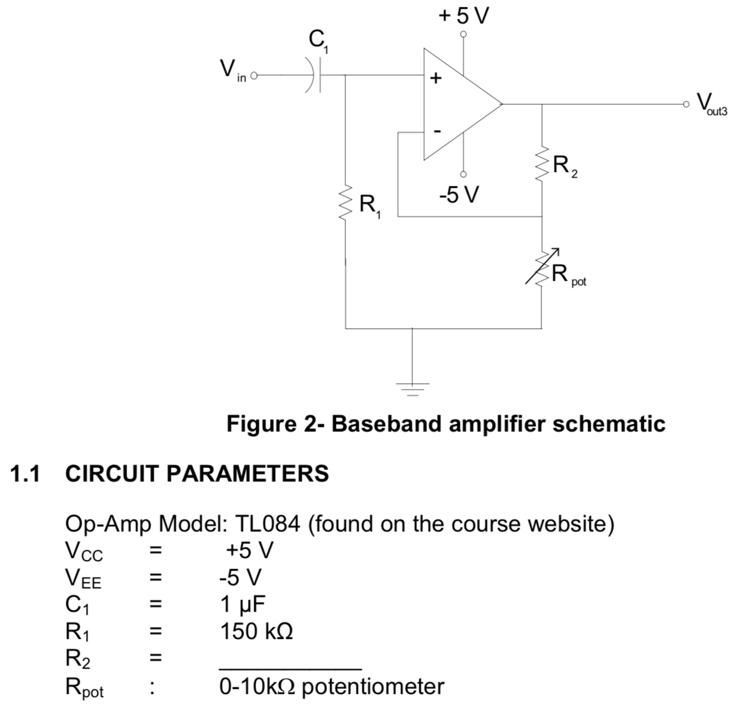

*Vx*

1. **Briefly explain the purpose of the capacitor C1.**

The position of the capacitor shows us that the circuit is a high pass filter. It serves to remove the DC component of the input signal. The demodulated signal will have reduced amplitude, which gets amplified by the baseband amplifier. The AC component of the signal gets amplified, but it is superimposed on the DC component. The capacitor C1 is known as DC blocking capacitor. When ω = 0 at DC frequencies, impedance of C1=Z=will go to infinity. The capacitor acts as an open circuit, blocking the DC component.

1. **Briefly explain the purpose of the resistor R1.**

The resistor serves as a path for the input bias current to flow through to ground.

1. **Derive the gain equation of the circuit shown in figure 2. Perform the analysis both for C1 neglected, then when it is taken into account. How does C1 affect the gain of the circuit?**

For both cases, assuming ideal Op-Amp conditions:

*V+* = *V-*

*I+* = *I-* = *0A*

Ignoring C1:

Including C1:

Further simplifying (2):

$$V_{x }\left(\frac{1}{R_{Pot }}+ \frac{1}{R_{2}}\right)= \frac{V_{out }}{R_{2}} (2a)$$

Solving for *Vx* in (1):

$$V_{x }= \frac{jwC_{1}V_{in }}{jwC_{1}+ 1/{R_{1 }}} (1a)$$

Plugging (1a) into (2a):

$$\frac{jwC_{1}V_{in }}{jwC_{1}+ 1/{R_{1 }}}\left(\frac{1}{R_{Pot }}+ \frac{1}{R_{2}}\right)= \frac{V_{out }}{R_{2}}$$

$$A_{v}=\frac{V_{out}}{V_{in}}= \frac{jwC_{1}R_{2}}{jwC_{1}+ 1/{R_{1 }}}\left(\frac{1}{R_{Pot }}+ \frac{1}{R_{2}}\right)$$

Adding the capacitor introduced complex numbers, as well as a frequency factor into the gain equation. It filters out the DC component. Depending on the value of C1, the gain is affected by a factor of $\frac{jwC_{1}}{jwC_{1}+ 1/{R_{1 }}}$.

1. **Choose values for R2 and RPot that will achieve an in-band gain of 150 V/V to the nearest 5% accuracy**

We know $A_{v}=\frac{V_{out}}{V_{in}}=1+ \frac{R_{2}}{R_{Pot}}$

And RPot has a range from 0 to 10kΩ

Thus, plugging in 150 V/V for Av and selecting RPot to be 5kΩ, we get:

$$150=1+ \frac{R_{2}}{5000Ω}$$

Solving gives R2 = 745kΩ

Rpot = 5kΩ

R2 = 745kΩ

Therefore,

The graph below gives a wider range of R2 and RPot combinations (Rpot range from 0 – 10kΩ), which gives a gain of 150V/V:

X (5k, 749k)

1. **Calculate the input and output resistance while neglecting C1.**

Assuming the input resistance of the Op-Amp is infinite, and the output resistance is 0 Ω:

Rin = R1 = 150kΩ

Rout = (R2 + RPot) || 0 = 0Ω

1. **Determine the 3-dB bandwidth of the circuit using SPICE simulator. Use the TL084 Op-Amp model found on the course website.**

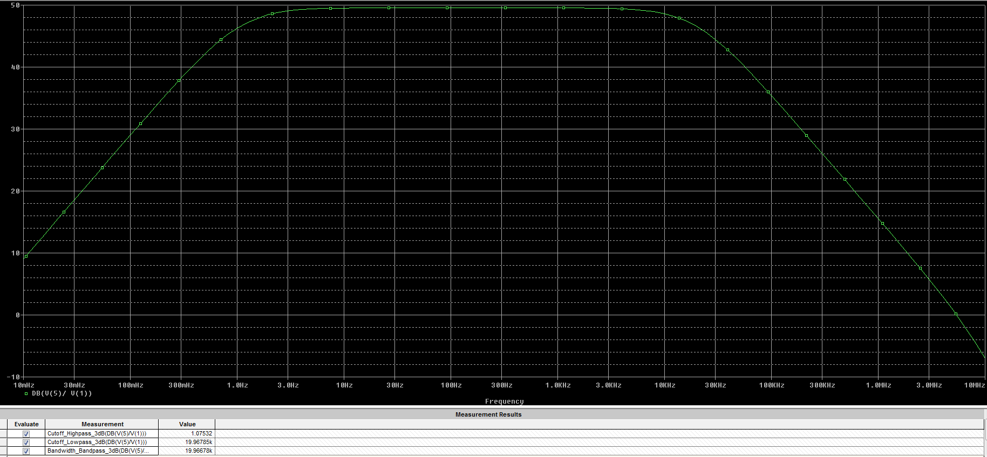

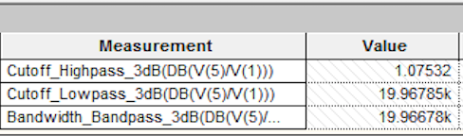

The Bandwidth was calculated to be approx. 20kHz. The table on the left shows the values as calculated by Pspice simulation.

1. **Vary the value of the potentiometer resistance, RPot, in order to modify the gain of the circuit, and to ultimately be able to construct a plot of the 3-dB cutoff frequency versus the in-band gain of the amplifier. Comment on the behavior of the curve and on the product of the 3-dB cutoff frequency by the in-band gain.**

|  |  |  |  |  |  |  |
| --- | --- | --- | --- | --- | --- | --- |
| **RPot (kΩ)** | **Cutoff (Hz)** | **Gain (V/V)** | **Gain (dB)** | | **cutoff freq*in-band gain** | |
| 0.5 | 1970 | 3001.00 | 69.5453 | 5911970.000 | |
| 1 | 3880 | 1501.00 | 63.5276 | 5823880.000 | |
| 1.5 | 5930 | 1001.00 | 60.0087 | 5935930.000 | |
| 2 | 7765 | 751.00 | 57.5128 | 5831515.000 | |
| 2.5 | 10000 | 601.00 | 55.5775 | 6010000.000 | |
| 3 | 11670 | 501.00 | 53.9968 | 5846670.000 | |
| 3.5 | 13430 | 429.57 | 52.6607 | 5769144.286 | |
| 4 | 15630 | 376.00 | 51.5038 | 5876880.000 | |
| 4.5 | 18035 | 334.33 | 50.4836 | 6029701.667 | |
| 5 | 19500 | 301.00 | 49.5713 | 5869500.000 | |
| 5.5 | 21345 | 273.73 | 48.7464 | 5842708.636 | |
| 6 | 23220 | 251.00 | 47.9935 | 5828220.000 | |
| 6.5 | 25260 | 231.77 | 47.3011 | 5854490.769 | |
| 7 | 27480 | 215.29 | 46.6603 | 5916051.429 | |
| 7.5 | 29900 | 201.00 | 46.0639 | 6009900.000 | |
| 8 | 32070 | 188.50 | 45.5062 | 6045195.000 | |
| 8.5 | 33925 | 177.47 | 44.9825 | 6020689.706 | |
| 9 | 35380 | 167.67 | 44.4889 | 5932046.667 | |
| 9.5 | 26905 | 158.89 | 44.0222 | 4275062.895 | |
| 10 | 39035 | 151.00 | 43.5795 | 5894285.000 | |

As the value of RPot is increased, the cut-off frequency also increases. The gain on the other hand decreases logarithmically (as shown in the graph below). The product of the cutoff frequency and in-band gain stays fairly constant at 5.9MHz*V/V.

1. **Considering the function of this circuit as a baseband voltage amplifier, what are the characteristics that this circuit should have regarding input impedance, output impedance and bandwidth?**

In order to reduce the loading effect on the demodulator, one should aim to have very high input impedance. For the output, it should be the opposite with very low output impedance to avoid loading. The bandwidth of the baseband amplifier should cover audible range from 20Hz to 20kHz.

1. **Suggest a method of intelligently measuring the input resistance, without requiring a current measurement.**

If we add another resistance in series with input resistance, and we know the resistance, we can measure the voltage across the known resistance and since we know the input voltage, we can calculate the voltage across the input resistance, and using that knowledge and voltage divider rule; we can calculate the input resistance.

*Vin* = *Vinput resistance* + *Vadded resistance*

*Vin*- *Vadded resistance* =

Solve the above equation to get the value of input resistance.